∗
Pittsburgh Bike Share Data: Progress Report

AYUSH MISHRA (amm428@pitt.edu) | JUNWEI ZHUGE (juz25@pit.edu)

ABSTRACT
The aim of this project is to predict the bike share counts for different stations across the city of Pittsburgh. The raw data is transformed to obtain actual results. In this Progress report, we made use of K-NN, LOGISTIC REGRESSION(LR) and NAÏVE BAYESIAN(NB) methods to train our model and predict the counts. A further aim is also to compare these counts against the rack quantities at each of the bike stations. The predictions based on our models can help determine the optimum time matrix to “re-balance” the bike accumulation and restore them to their optimum levels across the city.

INTRODUCTION
In this report, we first combine the Q3 and Q4 bike share data into a single entity to ease the processing. This gives us a consolidated view of the data and we can work on this to give us a better view of the response variable that we need to predict. At this point however, we do not have the actual response variable. We further process the dataset to get rid of “missing values”. After this, we split some consolidated columns such as “StartTime” and “StopTime into more edifying and workable columns.
Our goal is to predict the counts that are rented out and are deposited in to each of the stations each hour. Thus, we move one step forward by splitting the above mentioned consolidated columns into more processible data such as “StartMonth”, “StartDay”, “StartHour”, “StopMonth”…etc. This brings us closer to determining the response variable.
We aggregate the dataset by grouping together predictor variables and determining the counts. This count data is our response variable. The detailed methods of our predictions are shown in the following sections.

METHODS
For the initial processing we choose to apply K-NN(1,5,10), LR and NB methods to show the contrasts in the predicted data. We separate the counts to the ones that “Start” at a station and the ones that “Stop” at the stations. We merge these datasets to create a total counts dataset. We then create the training and test sets for predictors. These methods give us a peek at the prediction of the response counts as described in the following:

LOGISTIC REGRESSION
We extract the count data for the number of bikes rented out of a station named as the start station count (“StartCount”) and the number of bikes deposited in to a station named as station stop count (“StopCount”). The actual response variable for the model predictors are determined by the difference in start counts and stop counts each hour. This gives us a clear picture of the residual number of bikes at a given station (“Count”). This Count variable can have a positive or a negative value (StopCount – StartCount). A positive value means more number of bikes deposited in a particular hour than rented out. Negative value means more number of rentals than deposits. A zero value means rentals equal deposits for the particular hour.
The Logistic regression Model analyzes the Count response variable against all other dependent factors. Here, the predictor variables are “FromStationId”, “StartUserType”, “StartMonth”, “StartDay”, “StartHour”, “StartRackQnty”, “StopUserType”, “StopHour”. The data is normalized before putting through the process of classifier building. The model uses a probabilistic approach to predict the response variable with a cutoff probability = 0.5. The average error in probability prediction is also low, error = 0.0001620045. The model displays high Accuracy of results, Accuracy = 0.999838. Refer to “Table 1: LR Prediction” for the results. All results are via “k-fold” cross validation scheme with k = 10.

K-NN (K- NEAREST NEIGHBORS)
We analyze the data further with the K-NN analysis model. The results of the analysis with k = 1, are almost similar to the logistic regression model with the error = 0.0002400731. This is slightly higher than the LR model. Accuracy is also considerably lower, Accuracy = 0.834844. This means that the model performs moderately well with the data.
We further analyze the data with k = 5 and k = 10. The results seem to deteriorate with increasing k values with k = 1 being the best performing model. Refer “Tables 2,3 and 4”.

NAÏVE BAYESIAN
This method does not provide any good results and can be considered as a lower baseline of performances for models. See “Table 5” for the results of the evaluation.

PLOTS
A better view of the data exploration can be found via the following density plots. Upon analysis of these plots we were able to come up with the final entities that we want to include in our prediction:
“StationID”, “UserType”, “Month”, “Weekday”, “RackQnty”, and the "y" – the prediction variable bike trip count of a specific station at a day. It depicts both positive and negative values with "-" meaning final rented out quantities and "+" means deposited in quantities. So we can compute the final bike amount of a station in a given day. (We do not consider Hour for now to avoid sparsity which might affect prediction adversely.
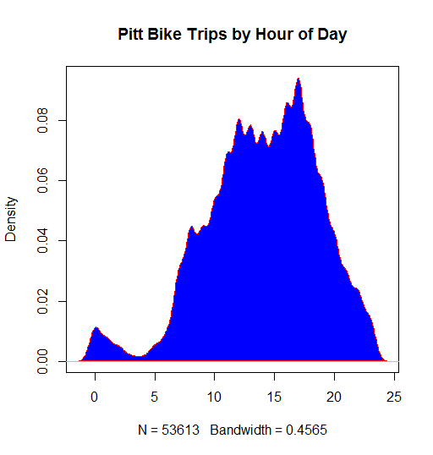

The above plot shows the “Density Plot” for Bike Trips by “the hour of the day”. This clearly depicts the fastigium of the Bike rental period in the day to be between hours “8-20”

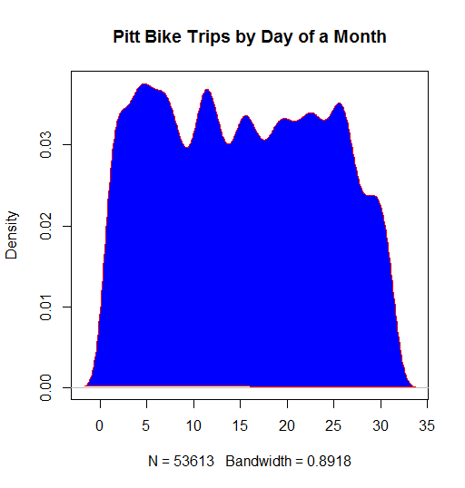

This is another interesting plot – “Bike Trips by Day of a Month”. Actually this plot provides the basis of our choice of actually treating the “Day” as weekdays and weekends instead of actual daily counts. The reason behind this is that it serves as a premise towards actual daily count predictions since we have better representation of data if we consider weekdays and weekends as opposed to the actual breakdown to each hour of the day. This allows us to decrease the sparsity in our data matrix and allows for better prediction performance.
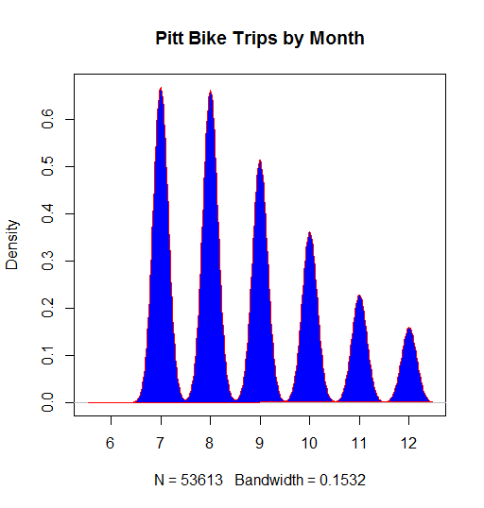

The “Bike Trips by Month” plot shows that rentals decrease as we move towards the end of the year with the highest number of rentals to appear in the month of “July”, constantly decreasing till it reaches the lowest number in “December”.

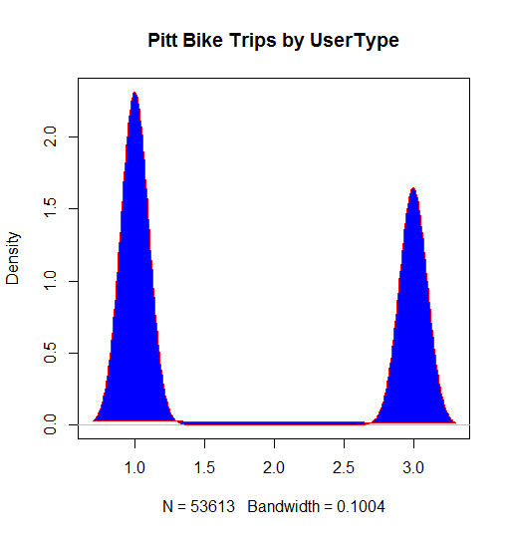

“Bike Trips by UserType” is another useful method to give us a perspective on the type of User (1 - Member (pay as-you-go customer), 2 - Subscriber (deluxe and standard monthly member customer), 3 - Daily (24-hour pass customer)). We can easily see here that the Type – 1 Users are the most active when it comes to using the bike rental service followed by Type – 3. The Type – 2 users in this case are fairly insignificant.

2.5 Tables
We show here the model performances of each of the prediction methods applied.

Table 1: LR Model predicted data
10 -fold CV run lr: #training: 99973 #testing 55554

actual 0 1
0 0 9
0.0227272727272727 0 2
0.0681818181818182 0 1
0.181818181818182 0 9
0.204545454545455 0 2
0.25 0 1
0.318181818181818 5 4
0.340909090909091 2 0
0.386363636363636 1 0
0.409090909090909 8 7
0.431818181818182 12 8
0.454545454545455 9 1
0.477272727272727 9 5
0.5 26 24
0.522727272727273 24 22
0.545454545454545 41 41
0.568181818181818 79 49
0.590909090909091 115 91
0.613636363636364 186 221
0.636363636363636 347 439
0.659090909090909 664 764
0.681818181818182 1286 1926
0.704545454545455 3213 5899
0.727272727272727 6581 21084
0.75 1174 6525
0.772727272727273 256 2145
0.795454545454545 77 1059
0.818181818181818 24 457
0.840909090909091 3 260
0.863636363636364 0 129
0.886363636363636 0 101
0.909090909090909 2 41
0.931818181818182 0 27
0.954545454545455 0 40
0.977272727272727 0 11
1 0 6

Table 2: K-NN Model (k = 1)
10 -fold CV run knn1: #training: 99973 #testing 55554

actual 0 1
0 0 9
0.0227272727272727 0 2
0.0681818181818182 0 1
0.181818181818182 2 7
0.204545454545455 0 2
0.25 1 0
0.318181818181818 6 3
0.340909090909091 1 1
0.386363636363636 1 0
0.409090909090909 5 10
0.431818181818182 4 16
0.454545454545455 1 9
0.477272727272727 5 9
0.5 12 38
0.522727272727273 22 24
0.545454545454545 19 63
0.568181818181818 61 67
0.590909090909091 93 113
0.613636363636364 187 220
0.636363636363636 320 466
0.659090909090909 546 882
0.681818181818182 1181 2031
0.704545454545455 2846 6266
0.727272727272727 6823 20842
0.75 2243 5456
0.772727272727273 745 1656
0.795454545454545 402 734
0.818181818181818 168 313
0.840909090909091 114 149
0.863636363636364 54 75
0.886363636363636 41 60
0.909090909090909 16 27
0.931818181818182 10 17
0.954545454545455 22 18
0.977272727272727 5 6
1 1 5

Table 3: K-NN Model (k = 5)
10 -fold CV run knn5 : #training: 99973 #testing 55554

actual 0 1
0 0 9
0.0227272727272727 0 2
0.0681818181818182 1 0
0.181818181818182 1 8
0.204545454545455 0 2
0.25 0 1
0.318181818181818 6 3
0.340909090909091 1 1
0.386363636363636 1 0
0.409090909090909 9 6
0.431818181818182 5 15
0.454545454545455 3 7
0.477272727272727 9 5
0.5 29 21
0.522727272727273 30 16
0.545454545454545 45 37
0.568181818181818 77 51
0.590909090909091 114 92
0.613636363636364 244 163
0.636363636363636 412 374
0.659090909090909 750 678
0.681818181818182 1557 1655
0.704545454545455 3797 5315
0.727272727272727 9247 18418
0.75 3074 4625
0.772727272727273 1123 1278
0.795454545454545 592 544
0.818181818181818 248 233
0.840909090909091 156 107
0.863636363636364 69 60
0.886363636363636 63 38
0.909090909090909 19 24
0.931818181818182 12 15
0.954545454545455 26 14
0.977272727272727 7 4
1 6 0

Table 4: K-NN Model (k = 10)
10 -fold CV run knn10 : #training: 99973 #testing 55554

actual 0 1
0 2 7
0.0227272727272727 2 0
0.0681818181818182 0 1
0.181818181818182 3 6
0.204545454545455 1 1
0.25 0 1
0.318181818181818 9 0
0.340909090909091 2 0
0.386363636363636 1 0
0.409090909090909 12 3
0.431818181818182 19 1
0.454545454545455 8 2
0.477272727272727 10 4
0.5 40 10
0.522727272727273 40 6
0.545454545454545 64 18
0.568181818181818 100 28
0.590909090909091 162 44
0.613636363636364 306 101
0.636363636363636 580 206
0.659090909090909 1036 392
0.681818181818182 2203 1009
0.704545454545455 5497 3615
0.727272727272727 13322 14343
0.75 4507 3192
0.772727272727273 1568 833
0.795454545454545 808 328
0.818181818181818 350 131
0.840909090909091 215 48
0.863636363636364 102 27
0.886363636363636 84 17
0.909090909090909 28 15
0.931818181818182 24 3
0.954545454545455 35 5
0.977272727272727 9 2
1 5 1

Table 6: Naïve Bayesian Model
10 -fold CV run nb : #training: 99973 #testing 55554

actual 0 1
0 0 0
0.0227272727272727 0 0
0.0681818181818182 0 0
0.181818181818182 0 0
0.204545454545455 0 0
0.25 0 0
0.318181818181818 0 0
0.340909090909091 0 0
0.386363636363636 0 0
0.409090909090909 0 0
0.431818181818182 0 0
0.454545454545455 0 0
0.477272727272727 0 0
0.5 0 0
0.522727272727273 0 0
0.545454545454545 0 0
0.568181818181818 0 0
0.590909090909091 0 0
0.613636363636364 0 0
0.636363636363636 0 0
0.659090909090909 0 0
0.681818181818182 0 0
0.704545454545455 0 0
0.727272727272727 0 0
0.75 0 0
0.772727272727273 0 0
0.795454545454545 0 0
0.818181818181818 0 0
0.840909090909091 0 0
0.863636363636364 0 0
0.886363636363636 0 0
0.909090909090909 0 0
0.931818181818182 0 0
0.954545454545455 0 0
0.977272727272727 0 0
1 0 0

FURTHER SCOPE
The analysis shown above is just a preliminary analysis of the data. We can use these models to predict actual counts on an hourly basis and can compare these data to the individual rack quantities at each of the stations and thus can determine the most appropriate times to “re-balance” the bikes for efficient bike sharing across the city.
In order to make this efficient, we shall explore further number of methods such as SVM, DECISION TREES and ADA.
For example, the K-NN method can be used to produce the actual count predictions as follows:

